

# ****School of InfoComm Technology****

**Deep Learning Assignment**

Diploma in DS / IT

Oct 2023 Semester

**ASSIGNMENT 1 Report**

(30% of DL Module)

**Submission Deadline:**

**Presentation: 9th Dec 2023 11:59PM**

**Report and Code: 9th Dec 2023 11:59PM**

|  |  |  |
| --- | --- | --- |
| **Tutorial Group** | **:** | **T01 / T02** |
| **Student Name** | **:** | Akul Arun |
| **Student Number** | **:** | S10243523 |

**Penalty for late submission:**

10% of the marks will be deducted every calendar day after the deadline.

**NO** submission will be accepted after 17th Dec 2023, 11:59PM.

# 

Table of Contents

1

School of InfoComm Technology 1

1. Introduction 4

1.1 The Problem 4

1.2 The Objective 5

1.3 The Approach 6

2. Data Preprocessing & Data Loading 7

2.1 Data Split Test 7

2.2 Image Size Test 8

3. Development of Classification Models 9

3.1 Baseline Model 9

3.2 Data Augmentation 10

3.2.1 Basic Data Augmentation 10

3.2.2 Data Augmentation With Colour and Lighting 11

3.2.3 Advanced Data Augmentation 12

3.2.4 Improving Realism of Augmentation 13

3.3 Image Classification Model from Scratch 15

3.3.1 Batch Size Test 15

3.3.2 Decrease Model Complexity 16

3.3.2.1 Removing Second Last Dense Layer 16

3.3.2.2 Reducing Image Size 17

3.3.3 Increasing Model Complexity 19

3.3.3.1 Testing Filter Size 19

3.3.3.2 Testing Number of Convolutional Layers 20

3.3.4 Testing Number of Max pooling 21

3.3.5 Testing Batch Normalisation 22

3.3.6 Testing Activation Function 23

3.3.7 Testing Type of Pooling 24

3.3.8 Testing Optimizer 25

3.3.9 Increasing Learning Rate 26

3.4 Image Classification model Utilizing Pre-Trained Models (Transfer Learning) 29

3.4.1 Feature Extraction Without Augmentation 30

3.4.2 Feature Extraction With Augmentation 32

3.4.3 Model Fine-Tuning 33

3.4.3.1 Unfreezing Last 2 Layers 33

3.4.3.2 Unfreezing Last 3 Layers 34

4. Evaluation of Models using Test Images 35

4.1 Baseline Model Evaluation 35

4.2 Scratch Model Evaluation 36

4.2.1 Batch Size Test 36

4.2.2 Decreasing Model Complexity 36

4.2.2.1 Removal of Dense Layer 36

4.2.2.2 Image Size Reduction 36

4.2.3 Increasing Model Complexity 37

4.2.3.1 Increasing Filter Size 37

4.2.3.2 Increasing Number of Convolutional Layers 37

4.2.4 Decrease Number of Max Pooling Layers 37

4.2.5 Batch Normalisation 37

4.2.6 Activation Function 38

4.2.7 Pooling Type 38

4.2.8 Optimizer 39

4.2.9 Learning Rate Scheduler 39

4.2.10 Dropout 39

4.3 Baseline vs Best Scratch 40

4.4 Pre-Train Model Evaluation 41

5. Image Classification using the Best Model 42

5.1 Classifying Strongest Food Class 42

5.1.1 Waffle Image With Little Noise 42

5.1.2 Waffle Image With More Noise 43

5.2 Classifying Weakest Food Class 44

5.3 Finding out how model classifies Wrong Images 45

6. Summary & Reflection 46

6.1 Further Improvements 47

6.2 Personal Reflection 47

# Introduction

In this section of the report, we will be delving into the overview of this project, more specifically, I will be discussing more about the problem at hand, the objective of this project, and the approach that I have taken in executing this project.

### The Problem

There are millions of different types of food around the world and so many different types of food look so similar to each other. An example that I can think of the top of my head is chickpeas and soybeans.

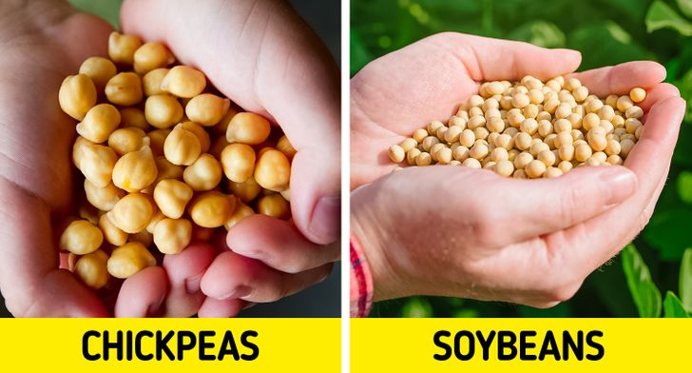

As seen from the image above that shows the pictures of chickpeas and soybeans, it is extremely difficult to tell these two food types apart as the colour of these 2 foods is similar and the overall shape of this two is also similar as they are both shaped like a sphere. However, there are subtle differences between these two foods that can be identified upon closer inspection. One of these differences is that chickpeas have a different texture from soybeans. Chickpeas have a rather rough texture as they are unevenly shaped while on the other hand, soybeans have a smoother texture and are rounder.

Apart from differentiating between two different food types, dishes belonging to the same food type but that look different can be challenging to categorize.

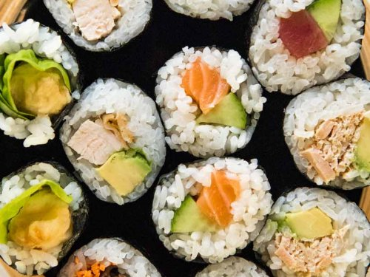

A popular example is sushi. As seen from the image above, there is a variety of ingredients used in sushi and ingredients used in one sushi might not be used in another sushi. However, they still belong to the same category of food. Even though each sushi can look different from each other in terms of colour, size and shape, there are also commonalities between them and in the example above it is rice; Rice is used as a key ingredient for all the sushi and that is the common pattern which can be used to classify them.

However, the advancement of technology has introduced image classification models which can ease this task for humans so that we do not have to waste so much time examining images and classifying them into different categories ourselves as this would take too much effort and would be too time-consuming. Image classification models must get trained on a certain number of different images so that it would be able to learn about commonalities between the food of the same class and soon it will be able to classify new images on their own. That brings us to the objective of this project.

### The Objective

The objective of this project is to create an image classification model using deep-learning techniques that is able to recognize and classify food images. The food types that I will be classifying are:

1. Chicken Quesadilla
2. Crème Brulee
3. Croque Madame
4. Fish And Chips
5. Foie Gras
6. Fried Rice
7. Paella
8. Poutine
9. Tacos
10. Waffles

### The Approach

I will be sharing more on the steps taken for this project and my idea behind why I have decided to follow the workflow that I am about to share. I took a rather systematic approach when building my models and did my model testing step-by-step.

First, I began with the data preprocessing and started off with the 75:20:5 split for the train, validation and test data. I wanted to try out how other splits affected my model so I created a baseline model so that I could test the train, validation, and test split and the image size. The baseline model also helped me evaluate the complexity of the problem and helped me understand if I needed to create a more complex model.

After creating the baseline model, I played around more with the splitting of the data which changed the compositions of the data split and found the best split by looking at the baseline model performance.

After I was satisfied with the data split, I tested the baseline model performance with a variety of image sizes.

Then I commenced on testing out data augmentation before starting to build models. By testing data augmentation techniques first, I ensured that I was working with a robust set of training data that will allow the model to generalize well to unseen data.

I decided to test these 3 factors first because these two factors would remain unchanged as I progress through more model testing as these 3 factors can affect the choice of model architecture and model hyperparameters.

Then, I could commence on building my actual models. At first, I wanted to focus on building my model architecture first and perfect my model architecture before moving on to hyperparameter tuning. However, when I was testing, I realised that model architecture testing and hyperparameter tuning go hand in hand together and should be tested together. After doing a few architecture tests, I realised that I had to first test batch size before any architecture test so I had to revert back to my original architecture. Then when testing different model architecture, I had to make changes to the optimizer and the learning rate and add regularisations.

After I had created a scratch model, I used transfer learning to create another model. I evaluated these models and chose the best model for image classification.

# Data Preprocessing & Data Loading

### Data Split Test

I felt like this was a relatively small dataset and I found that it was common practice to assign more images to the train set in cases of a small dataset so that the model has enough data to draw enough insights and uncover patterns from.

As a result, I decided to test out more data splits where I increased the number of images in the train set. The two other splits I tested were the popular 80:10:10 split and the 85:10:5 split.

75:20:5 Split Test

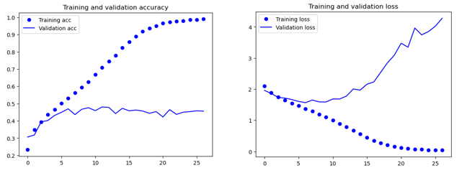

80:10:10 Split Test

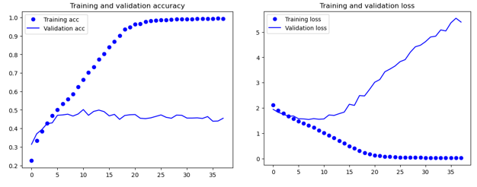

85:10:5 Split Test

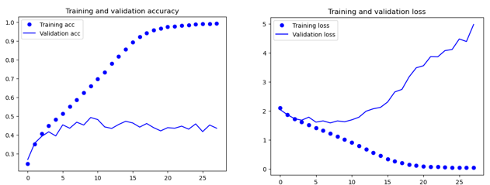

After increasing the number of training data, the model performance did not have any significant changes and the validation accuracy of the model remained around the same value. However, the model tends to be more noisy as the value for the train split is increased and the rate of overfitting is also faster as demonstrated by the steeper gradient of the curve of the 80:10:10 and 85:10:5 split tests.

A smaller validation set may not accurately represent the diversity and complexity of the entire dataset, making it more prone to noise. Also, the model might not have enough diverse samples and the validation set might not be representative of the training set so the model cannot generalize well to unseen data, leading to overfitting and noise. Additionally, data augmentation can be carried out later for the model to have more images to train from so I decided to stick with the 75:20:5 split.

### Image Size Test

Standardizing all image sizes simplifies the design of the model architecture as it allows for the architecture to be defined with a fixed number of input nodes.

Since image size directly affects the architecture and the complexity of the model, image size can make a difference in the accuracy of the model. It can affect the number of layers the model has, the pooling operations of the model, etc. That is why I decided to test the image size of the model. The image sizes that I tested were 150, 200, 224, 250 and 300. I did not want to test smaller image sizes as my machine had enough computational capability to handle bigger sizes.

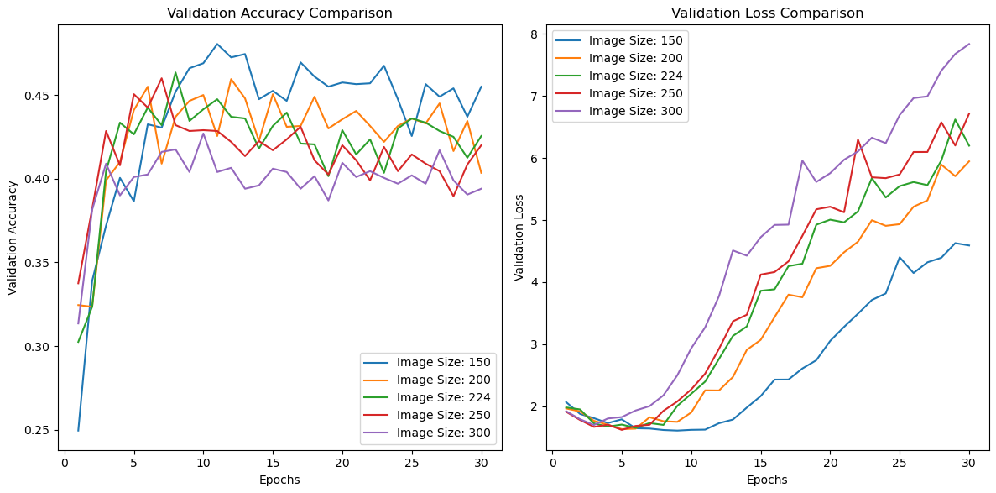

As seen from the graphs, bigger image sizes did not always perform better as seen by the lower accuracies and higher rate of overfitting. However, this could also mean that the model was not complex enough to detect relevant features in the bigger-sized images which is why the smaller-sized images performed better.

However, I decided to use image size 224 as many pre-trained models released by experts have been trained on this image size and many competition winning models have been trained on image size 224.

This image size also ensures computational efficiency as 224x224 images are large enough to capture meaningful details, but are not overly large, helping to strike a balance between computational efficiency and information content.

# Development of Classification Models

In this section of the report, we will be taking a deeper look at the steps taken to create the classification models from scratch and using transfer learning.

### Baseline Model

I have referred to a “baseline model” previously in the report and you might wondering what that is. A baseline model is a simple, minimal-effort model used as a reference point for evaluating the performance of more complex models.

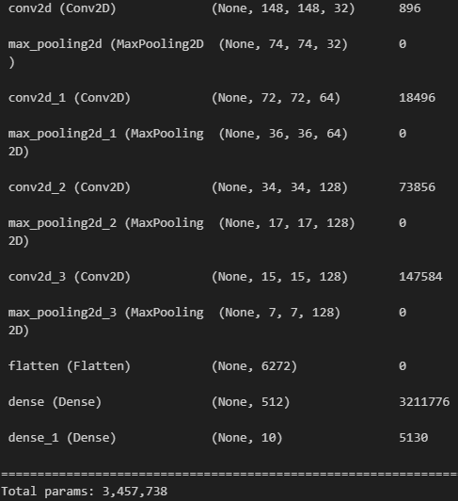

Baseline Architecture 1

My baseline model had 11 layers and 3 million parameters which I thought was a good starting point. I used it to test image size and data augmentation and built my scratch model based on it.

### Data Augmentation

Data augmentation artificially creates new images and through augmentation, a greater diversity of images enhances the model's ability to recognize patterns that are invariant across various instances, increasing accuracy on unseen data and the model will not be learning the patterns of the train set too fast, reducing overfitting.

### Basic Data Augmentation

I started off by applying changes to the position and angle of the food by methods such as rotating and shearing.

Before Basic Augmentation

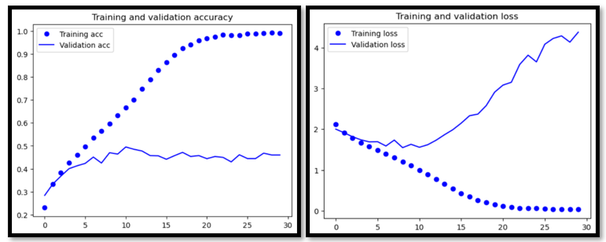

After Basic Augmentation

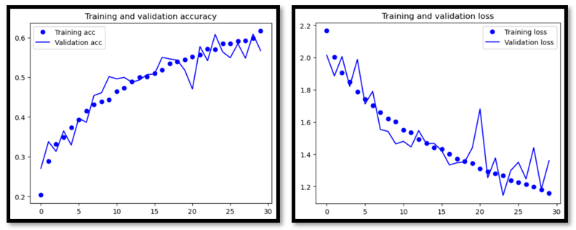

Before augmentation, the model started overfitting by the 10th epoch but after augmentation, even after 30 epochs, the model does not show any signs of overfitting.

Also, before augmentation, the validation accuracy stagnated at around 45% but after augmentation, the validation accuracy peaked at 60% and still shows signs of increasing.

However, the model training has also become noisier after augmentation, and this is expected due to the increased variability in the train set.

### Data Augmentation With Colour and Lighting

Basic augmentation shows positive effects so I added slight colour and lighting augmentations, ensuring that the images still looked realistic.

Before Colour & Lighting Augmentation

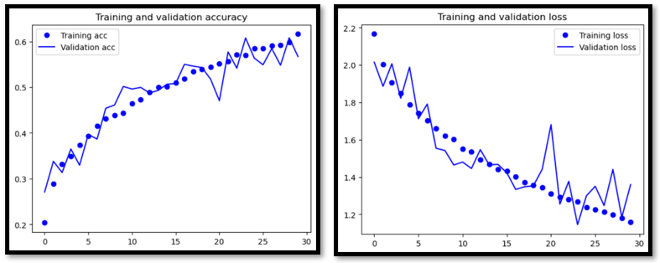

After Colour & Lighting Augmentation

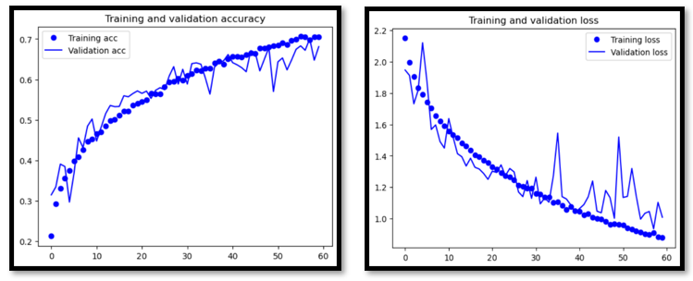

Before, the validation accuracy was below 60% at the 30th epoch but it increased past 60% to around 63% after. Before, the validation loss could not decrease past 1.2 in 30 epoch but after, it did. Increasing the model exposure to more colours and lights improved the model performance.

### Advanced Data Augmentation

I tried more advanced data augmentation techniques such as random hue, gaussian blur, adaptive histogram equalization and colour jittering to further expose the model to more colours.

Before Random Hue & Gaussian Blur

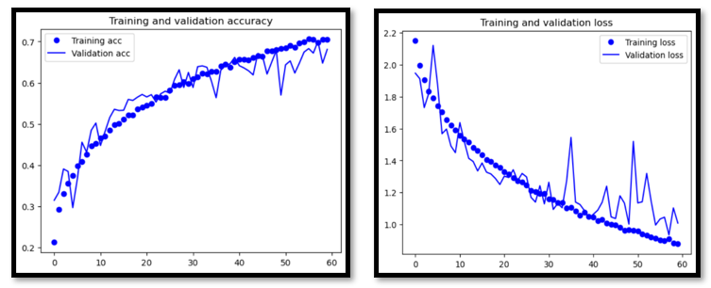

After Random Hue & Gaussian Blur

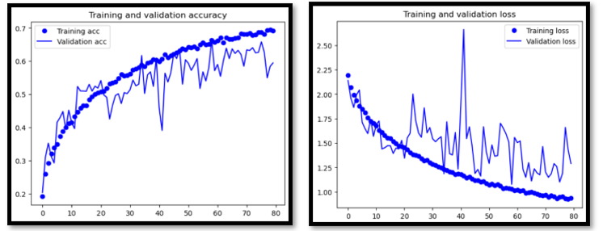

The random hue and gaussian blur did not have a positive effect on my model as it increased the validation loss, accuracy and increased the noise of my model. The validation loss was around 1.25 and showed a slight general decrease and the accuracy stagnated at around 60%.

Excessive hue shifts can distort color information crucial for classification, while excessive blur may hinder the model's ability to focus on relevant details.

### Improving Realism of Augmentation

I had to make sure the image variations were realistic as augmentations producing unrealistic images cause the model to learn patterns or features that are not present in real-world data, leading to poor performance when deployed in actual use cases.

Rotation Range = 40 Image:

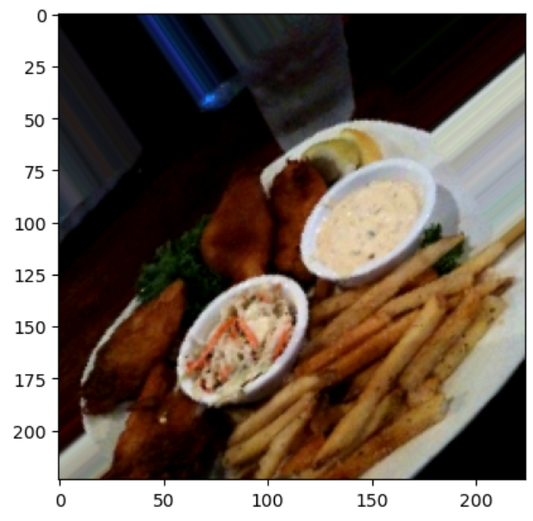

I realized my rotation range was too high as the food looked too tilted and if this happened in real life, the food would just fall off.

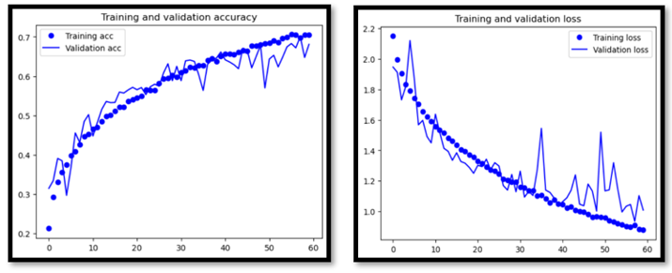

Model Performance With Rotation Range 40

Rotation Range = 20 Image:

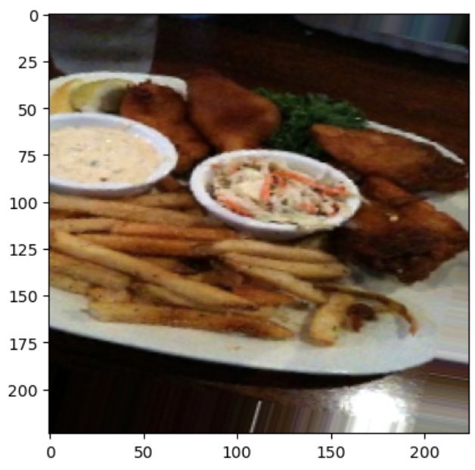

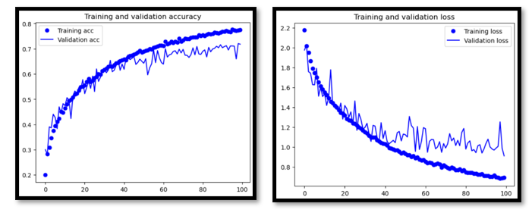

Model Performance with Rotation Range 20

I reduced the rotation to a more realistic angle and the model performance managed to break the 70% accuracy mark and the validation loss also decreased past 1.0 after reducing the rotation range. The decrease in variability made the model less noisy.

### Image Classification Model from Scratch

Since data-related tasks are done, I could commence model building, starting with a sequential model with conv2d layers.

### Batch Size Test

Batch size is number of training samples used in one iteration for optimization.

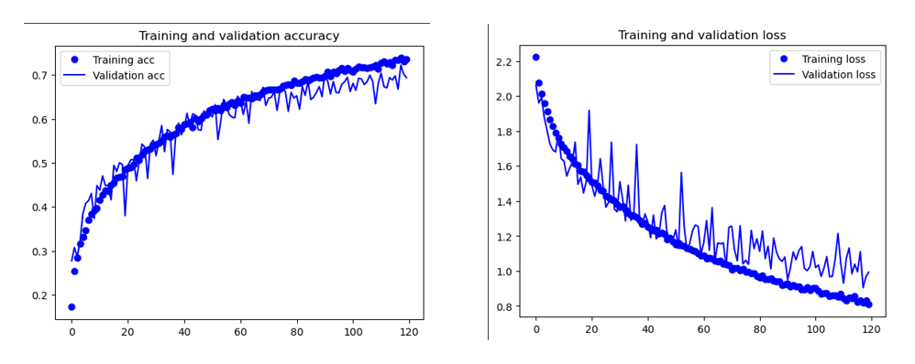

Batch Size = 20

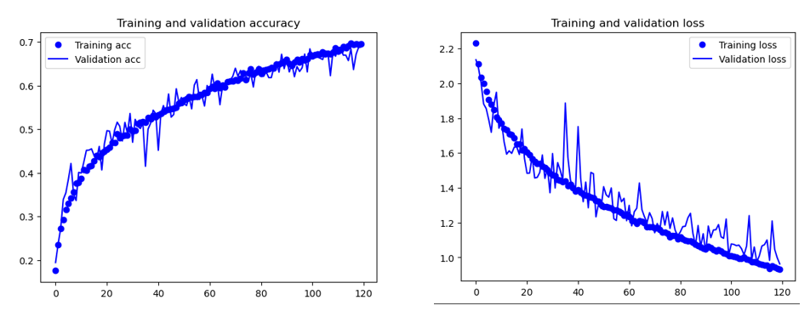

Batch Size = 32

My baseline model was using batch size of 20 but I decided to increase the batch size for faster training and improved training stability. My model became less noisy and started to overfit slower as the gap between validation loss and training loss is closer. The validation loss was similar for both models at 1.0 at epoch 120. I decided to continue with 32 as I felt the benefits of faster training outweighed the little drop in performance.

### Decrease Model Complexity

I wanted to experiment with simpler models as my dataset was small and would not require a highly complex model.

### Removing Second Last Dense Layer

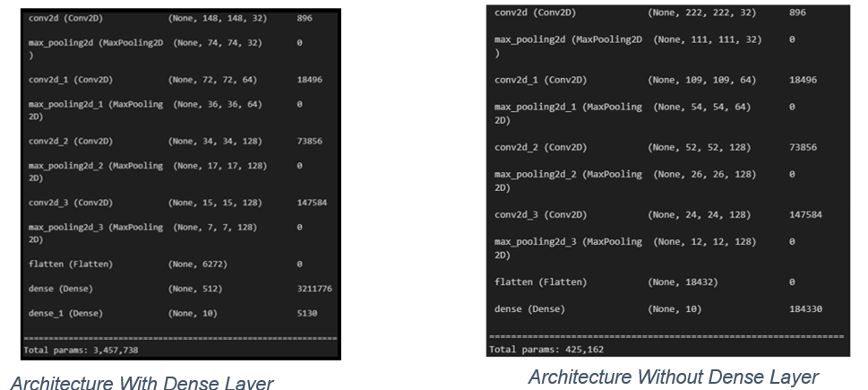

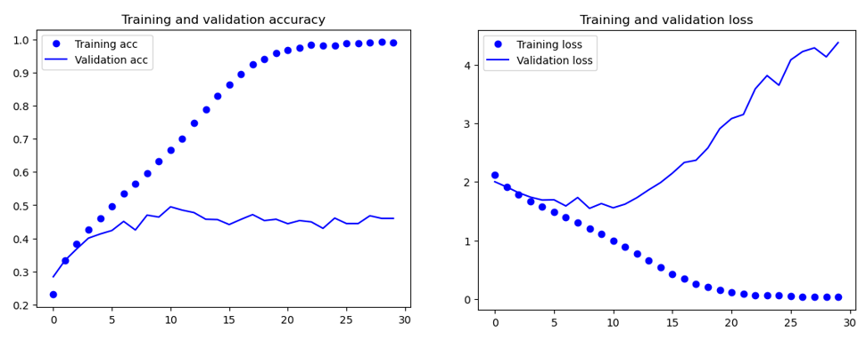

Model Performance with Dense Layer

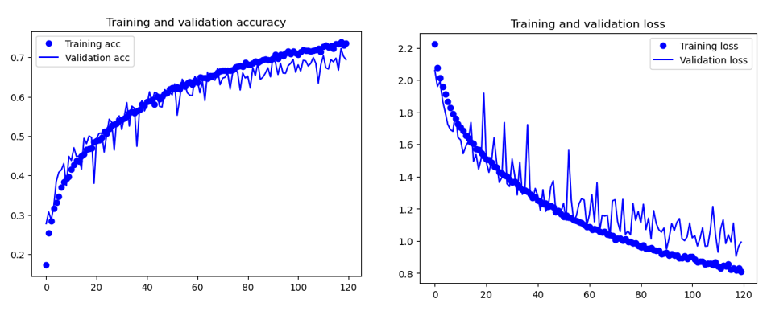

Model Performance Without Dense Layer

The number of params significantly dropped from 3 million to 400,000 after I removed the second last dense layer due to the elimination of connections and associated weight parameters. With the dense layer, my model was performing more poorly and overfitting at the 10th epoch but after removing it, the validation accuracy increased from 44% to 70% and was underfitting at the 120 epoch. The dataset is small so a simpler model would be more effective with lower risk of overfitting. Hence, I continued without a dense layer.

### Reducing Image Size

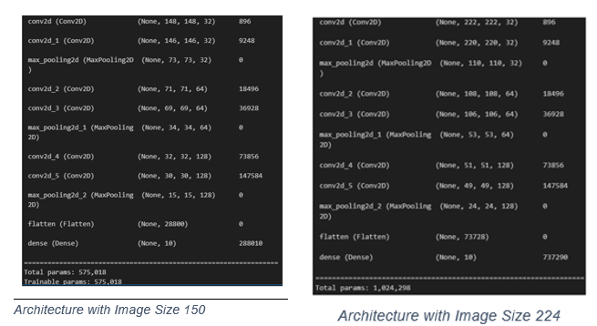

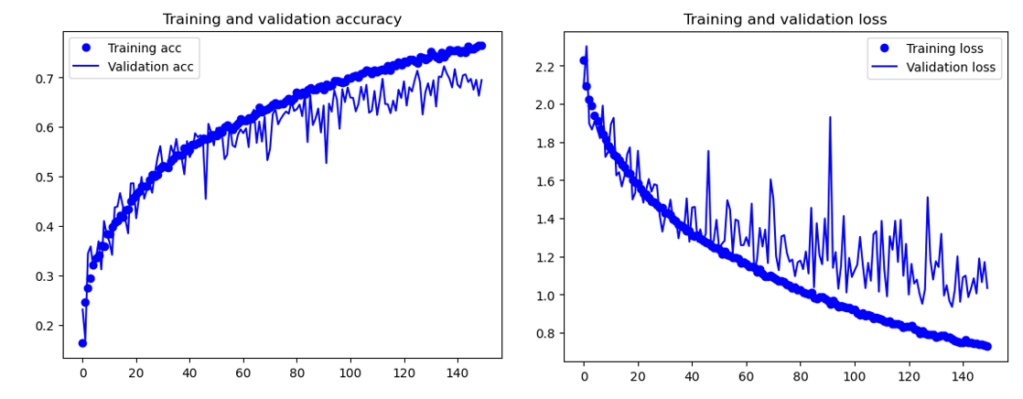

Model Performance with Image Size 150

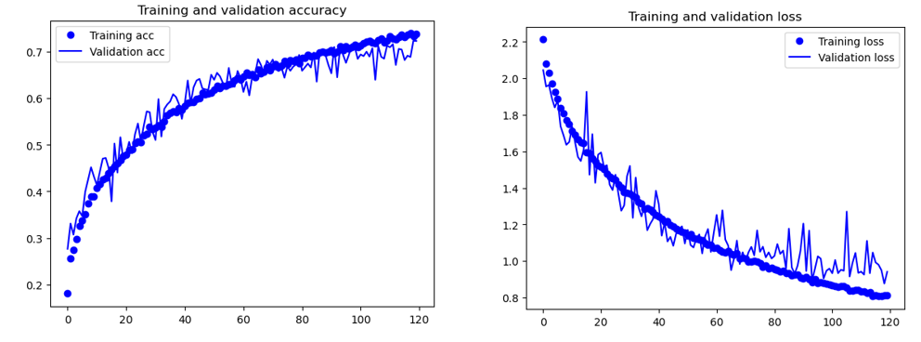

Model Performance with Image Size 224

The decrease in image size from 224 to 150 halved the number of params. I decided to decrease my image size to speed up the runtime of my model as I felt my model was taking too long to train at 100 seconds per epoch for 120 epoch. Image size 150 caused the validation loss of the model stayed above 1.0 before it could decrease to 0.9 at epoch 120 and became more noisy due to the loss of detailed information, making it challenging for the model to distinguish relevant features and patterns in the images. Hence, I stuck to 224.

### Increasing Model Complexity

### Testing Filter Size

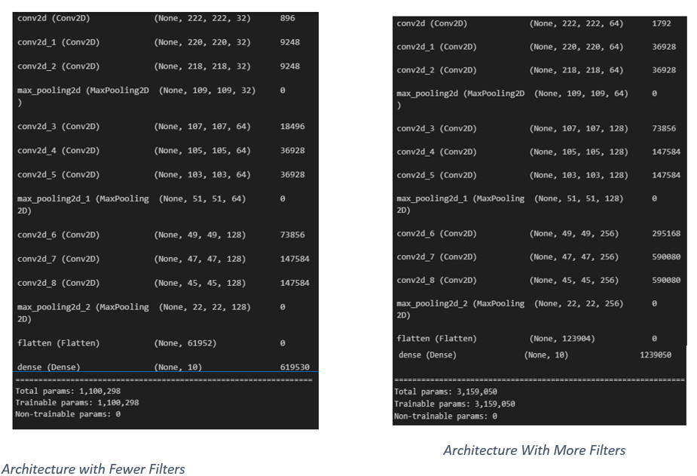

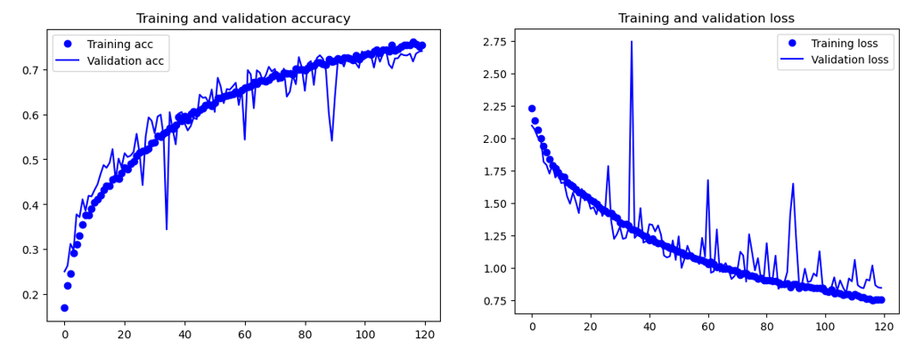

Model Performance with Less Filters

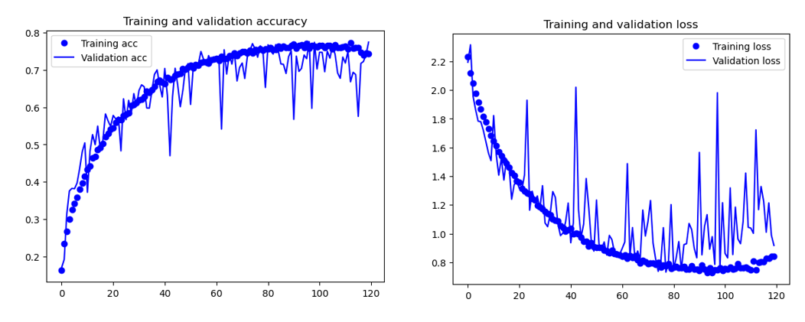

Model Performance With More Filters

I doubled the filters in each layer and the number of params of my model tripled. Increasing the filter size made my model too complex. However, the model became too noisy and started to overfit faster at around epoch 100 due to the increased complexity as more filters could capture more complex patterns and noise in the training data which can be undesirable as the model will fail to generalise to new data. Hence, I stuck to the original number of filters.

### Testing Number of Convolutional Layers

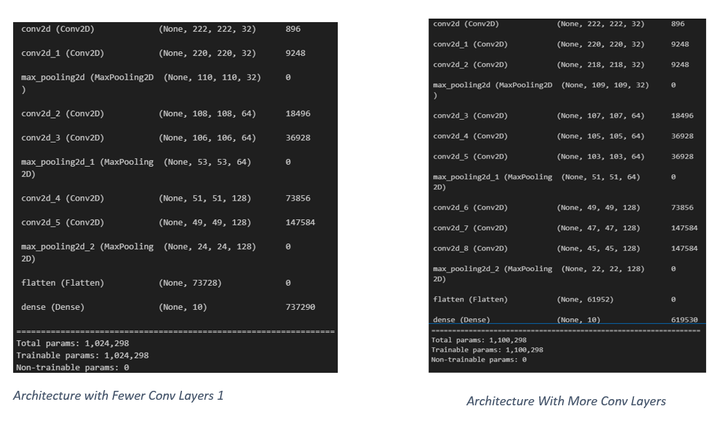

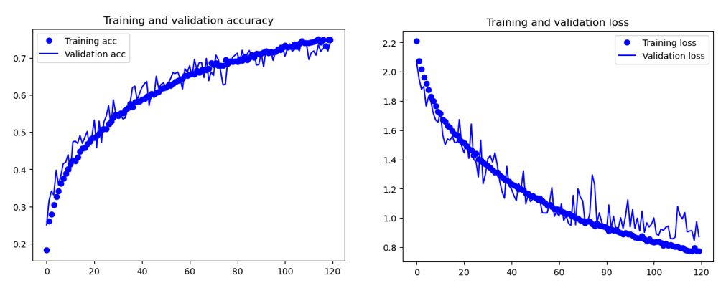

Model Performance with 2 Layers



Model Performance With 3 Layers

The addition of more convolutional layers has minimal change to the model complexity and params as convolutional layers typically share weights across regions of the input. Before, my model achieved a validation loss of 0.95 at epoch 120 but after more convolutional layers, my model achieved a validation loss of around 0.85 at epoch 120. Hence, I decided to continue with 3 convolutional layers.

### Testing Number of Max pooling



Model Performance with Less Max Pooling

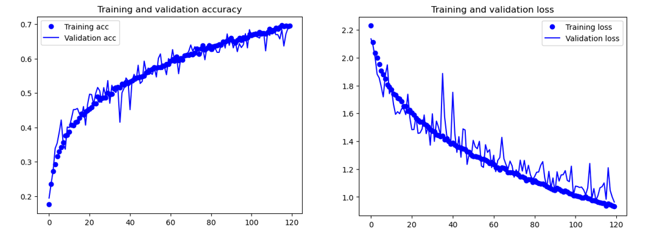

Model Performance With More Max Pooling

Removing a max pooling layer improved the performance of my model and it managed to break past 70% accuracy and its validation loss decreased from around 1.0 to around 0.9 at epoch 119. Reducing max pooling layers preserves more spatial details which improves model generalization. Hence, I continued with 1 less max pooling layer.

### Testing Batch Normalisation

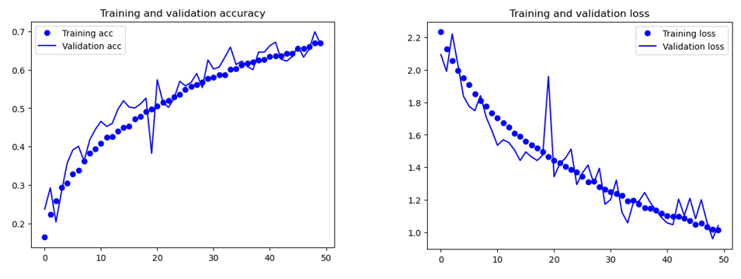

Model Performance Without Batch Normalisation

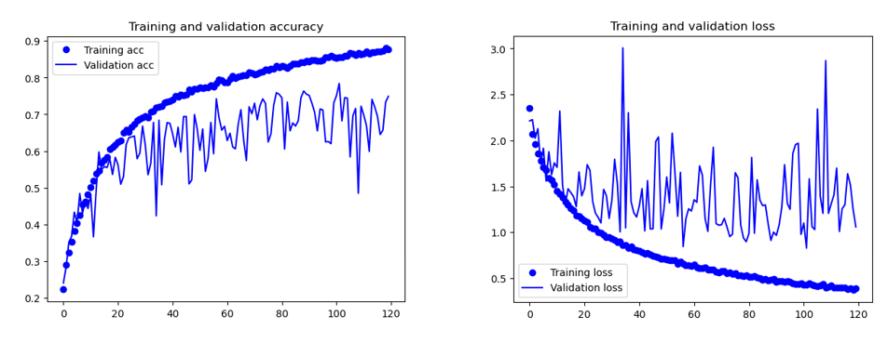

Model Performance With Batch Normalisation

I decided to implement batch normalization for faster training as it is a technique that normalizes the inputs of a neural network layer to have zero mean and unit variance and quickens the convergence of the model. However, batch normalization had negative effects as it introduced too much noise and stagnated at a validation loss of around 1.0. Without batch normalization, the model still shows signs of further decrease from validation loss 1.0. Batch normalization may have been noisy due to inaccurate estimates of mean and variance due to small batch size. Model with too much noise will fail to generalize to new data so I decided to continue without batch normalization.

### Testing Activation Function



Model Performance With ReLu Activation

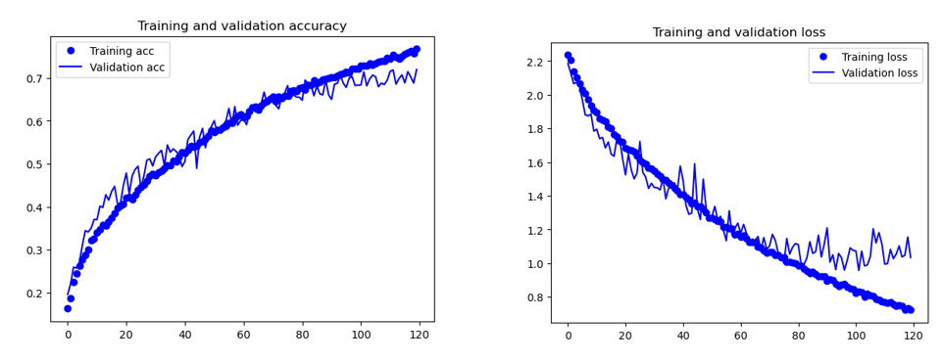

Model Performance With Swish

I decided to test some activation functions and find out their effect on my model. I decided to implement swish to reduce noise as is a smooth, non-monotonic function that tends to reduce the vanishing gradient problem. The swish activation decreased the model performance as the model with ReLu achieved a validation loss of 1.0 in 50 epoch and was still underfitting and the model with swish started overfitting after epoch 80 after achieving validation loss of 1.0. Its non-monotonic nature might have affected model convergence and performance. Hence, I continued with ReLu activation.

### Testing Type of Pooling



Model Performance With Max Pooling

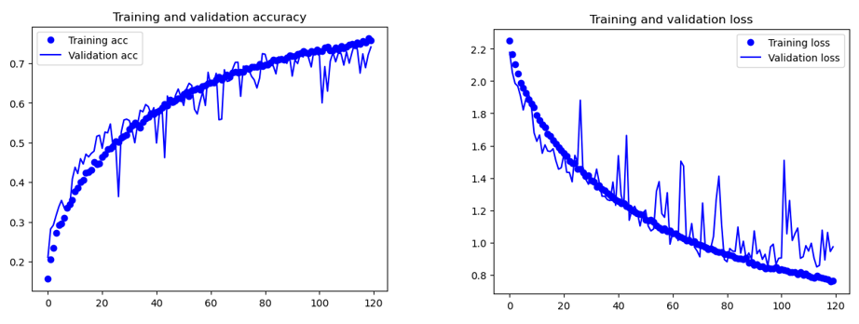

Model Performance With Average Pooling

Average pooling region in the input is replaced by the average value of that region, reducing the spatial dimensions of the data. However, the model performed better with max pooling because at the 50th epoch, the validation loss of the model with max pooling was 1.0 but that of the model with average pooling was still around 1.1. Max pooling retains more prominent features by selecting the maximum value within each pooling region, allowing the model to capture more distinctive patterns and improve performance. Hence, I continued with max pooling.

### Testing Optimizer



Model Performance with RMSProp

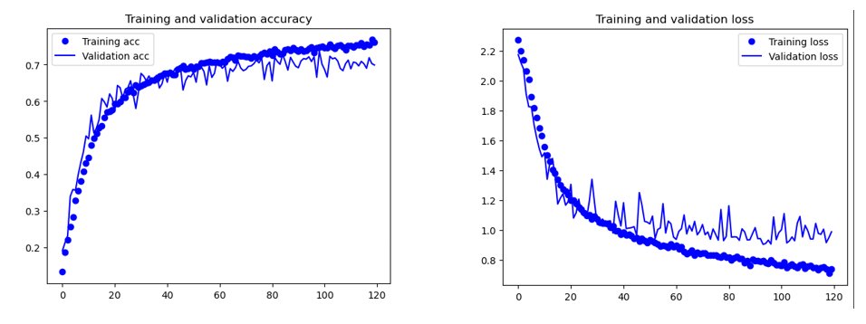

Model Performance with Adam Optimizer

Optimizers can impact convergence speed, model stability, and the ability to escape local minima, affecting overall training efficiency and performance. I decided to test the Adam optimizer because I wanted a faster runtime as it combines the benefits of momentum and RMSprop, adapting the learning rates for each parameter individually. However, the Adam optimizer made my model perform more poorly than the RMSProp optimizer. With Adam, the model started overfitting at epoch 45 and its validation loss stayed around 1.0 but the model with RMSProp did not overfit and managed to achieve a validation loss of around 0.9 at epoch 120. Hence, I continued with RMSProp optimizer.

### Increasing Learning Rate



Model With Learning Rate 0.0001

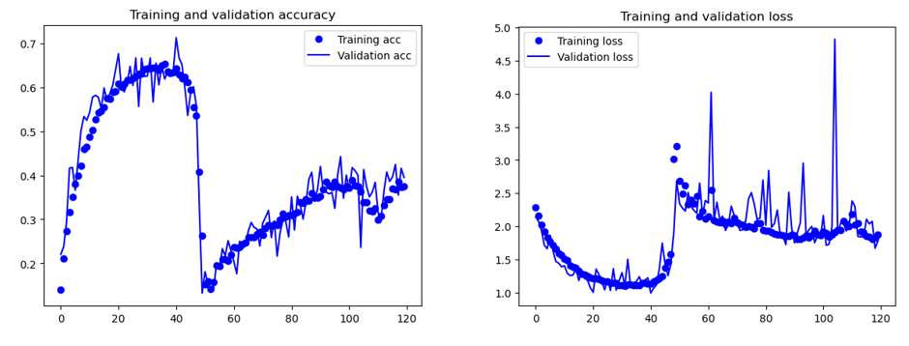

Model With Learning Rate 0.0005

The learning rate can affect the speed at which the model trains which is why I increased the learning rate from 0.0001 to 0.0005. However, the model faced a sudden drop in accuracy and a sharp increase in loss which indicates divergence due to the learning rate being too high and the parameters changing too quickly, causing the model to overshoot the optimal solution. Hence, I continued with 0.0001 learning rate.

* + 1. **Testing Learning Rate Scheduler**



Model Performance Without Learning Rate Scheduler



Model Performance With Learning Rate Scheduler

I decided to use learning rate scheduler to dynamically adjust the learning rate which can improve model convergence. I used an exponential decay function which is ideal for gaussian type noise. However, the learning rate scheduler did not improve my model performance and my model had a higher validation accuracy over 70% without learning rate scheduler but barely managed to hit 70% percent accuracy with the scheduler in the same number of epochs. The validation loss graph and training loss graph is further away of the model with scheduler than that of the model without scheduler, showing more overfitting. Hence, I continued without learning rate scheduler.

* + 1. **Testing Gradient Clipping**



Model Performance with No Gradient Clipping



Model Performance with Gradient Clipping

Gradient clipping can reduce model noise by limiting the magnitude of the gradients and reducing explosive gradients which can cause noise. Gradient clipping made the noise more consistent as the lengths of the heights and drops were more similar after gradient clipping.

* + 1. **Testing Dropout**

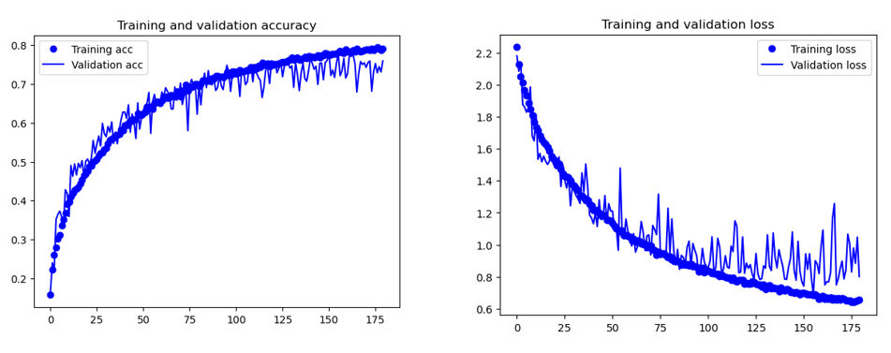

Model Performance Without Dropout

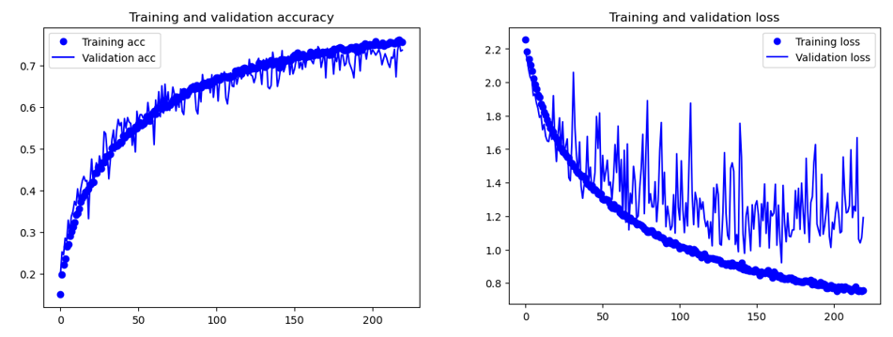

Model Performance With Dropout

The addition of dropout made my model perform worse as it had a lower validation accuracy of around 71% which was drop from around 75% and the validation loss of the model with dropout stayed at 1.0 after epoch 120 while the one without dropout managed to decrease to about 0.8 at the 150th epoch. In dropout, randomly selected neurons are "dropped out" or ignored, meaning their outputs are set to zero. Hence, the different active neurons in each epoch can lead to more noise. The accuracy dropped because dropping neurons can prevent information from propagating through the network fully which can lead to loss of important information. The loss of information made it harder for the model to learn generalizable features, leading to faster overfitting.

I did not apply regularisation such as dropout for previous test as my model was constantly underfitting even after long trainings.

I combined the best results from the previous tests to create my best scratch model.

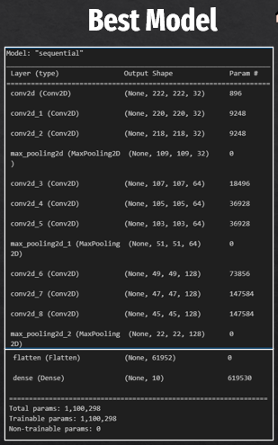

Best Scratch Model Architecture

### Image Classification model Utilizing Pre-Trained Models (Transfer Learning)

Transfer learning leverages knowledge from a pre-trained model on a related task to boost performance on a new task with less data, time, and computational power. Transfer learning will be crucial as I have a small dataset. I evaluated the pre-trained models in 3 key stages:

1. Feature Extraction without Augmentation
2. Feature Extraction With Augmentation
3. Fine-Tuning

I decided to test the MobileNet and VGG16 models due to the difference in complexity between them and I wanted to see how models of different complexities compared in my dataset. MobileNet uses depthwise and pointwise convolutions instead of standard convolutions, significantly reducing the number of parameters and computations while VGG16 uses standard convolutional layers stacked on top of each other.

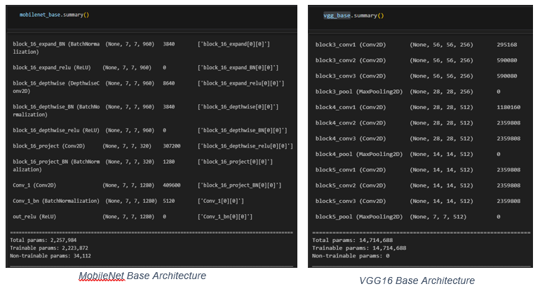

VGG16 base has 7 times the number of params as that of MobileNet.

### Feature Extraction Without Augmentation

Feature extraction without augmentation is important as the first step for transfer learning because it allows the pre-trained model to capture generic features from the source task without introducing variations or distortions. This initial feature extraction helps retain the valuable information encoded in the pre-trained model's weights.

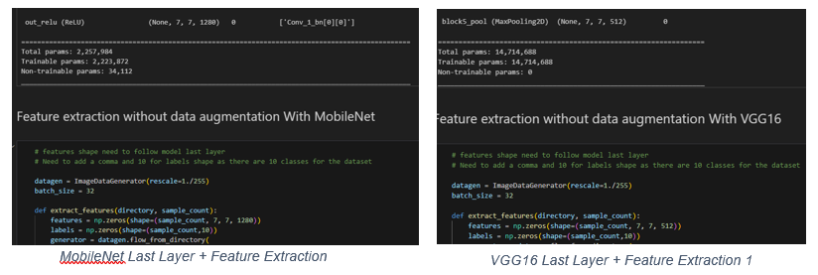

The last layer of MobileNet outputs a shape of (None, 7, 7, 1280) while the last layer of VGG16 outputs a shape of (None,7,7, 512). Hence, when extracting the features, we have to make sure the features variable follows the same shape. Additionally, the number of classes need to be specified in the labels variable, 10 in our case. The practical was a binary classification problem but in a multi class classification problem, we explicitly specify the number of classes. Next, we freeze the base, build the model and evaluate it.

When performing feature extraction on pre-trained models, dropout is typically not added to the layers responsible for feature extraction. Dropout is a regularization technique that involves randomly dropping out a fraction of neurons during training to prevent overfitting. In the context of pre-trained models used for feature extraction, these models have already been trained on large datasets and have learned valuable hierarchical features.

Adding dropout during feature extraction may disrupt the learned representations and hinder the transfer of knowledge from the pre-trained model to the new task.

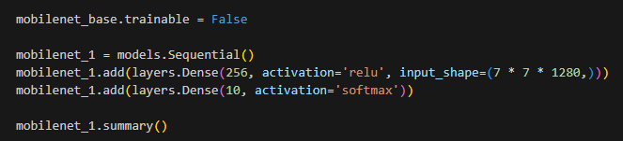

Freezing Base Layer

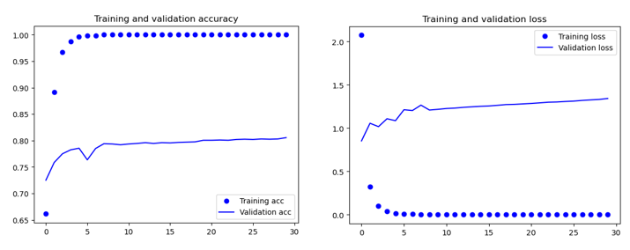

MobileNet Performance No Augmentation

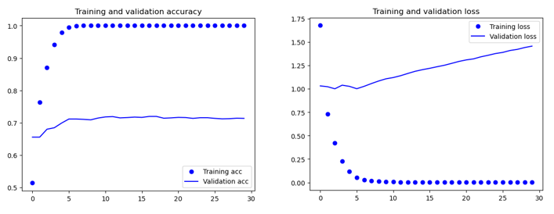

VGG16 Performance No Augmentation

The MobileNet model performs better than the VGG16 model and exceeds 80% accuracy while the VGG16 model only manages to hit around 71% accuracy. The VGG16 model also started to overfit faster at the 5th epoch while the MobileNet started overfitting at a slower rate around the 8th epoch as seen from the gradient of the validation loss. Hence, for subsequent tests, I continued using MobileNet.

### Feature Extraction With Augmentation

This is basically the same as before but now we will be introducing variability and distortions through augmentation. I tested out basic augmentations where I only applied positional and rotational changes to the images and advanced augmentation where I applied colour and brightness augmentations.



MobileNet Without Augmentation

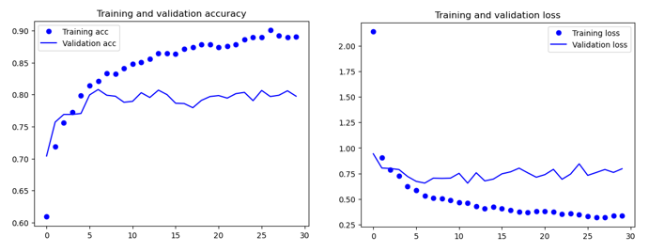

MobileNet With Basic Data Augmentation

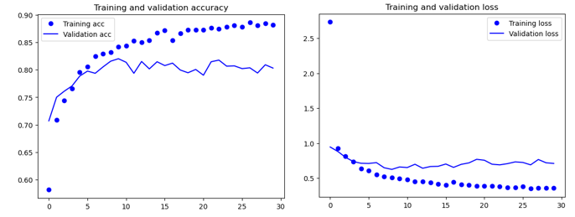

MobileNet With Advanced Augmentation

The basic augmentation was helpful as after the basic augmentation, the model started to overfit after reaching a lower validation loss of 0.7 at around the 6th epoch and achieved a higher validation accuracy of around 82% by epoch 8. The advanced augmentations did not prove to be useful as the validation accuracy was similar in both tests at around 82%.

### Model Fine-Tuning

Model fine-tuning is done to help the model adapt to the new task and dataset, and this is done by unfreezing the last few layers. It is recommended to only unfreeze the last few layers as lower layers capture more generic features, while higher layers may capture more task-specific features, and unfreezing only the latter allows the model to retain the broader knowledge from pre-training while adjusting to the new task.

### Unfreezing Last 2 Layers

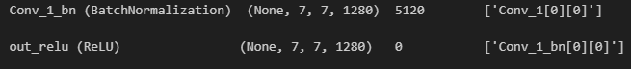

Last 2 layers of MobileNet

For the first fine tuning test, I unfroze the last 2 layers as there was no point unfreezing just the last layer due to it having 0 params.

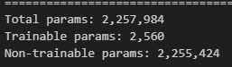

2560 Trainable params

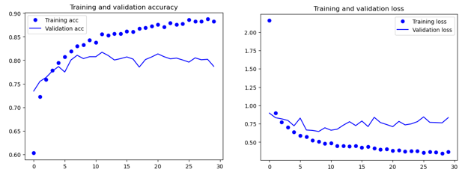

MobileNet performance after unfreezing last 2 layers

### Unfreezing Last 3 Layers

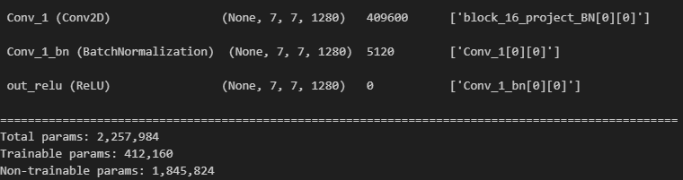

Layers Unfrozen and Trainable params

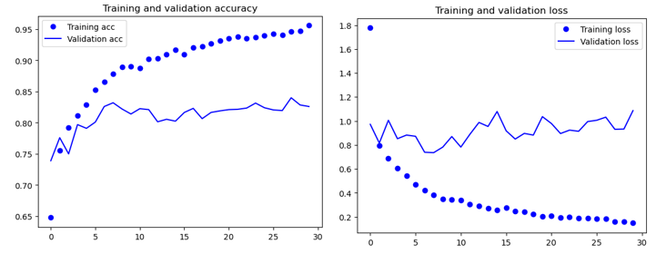

Model Performance After Unfreezing Last Layers

As we unfreeze more layers, the validation accuracy of the model increases. When the last 2 layers were unfreezed, the validation accuracy was around 79% at epoch 30. When the last 3 layers were unfreezed, the validation accuracy was around 82%. From the 5th epoch, the validation accuracy was constantly above 80%. This is because as more layers are unfreezed, the model captures more task-specific features.

# Evaluation of Models using Test Images

In this section of the report, I will explain the model evaluations that were done with the test images, and I will be deciding on the best model to continue with subsequent sections. Evaluating models on test data is crucial for assessing their generalization performance and determining how well they perform on new, unseen data. It helps ensure that the model has not merely memorized the training data (overfitting) but can make accurate predictions on real-world examples.

### Baseline Model Evaluation

I first started off by evaluating my baseline model on the test images as I wanted to compare it with my best scratch model to determine the amount of improvement my testings had made.

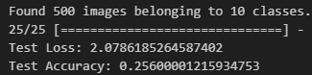

Test Evaluation of Baseline

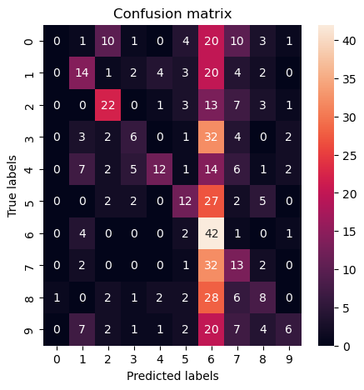

Confusion Matrix of Baseline Predictions

The reported test loss of 2.08 and test accuracy of 25.6% suggest that the model's performance on the test data is currently not optimal. The high loss indicates a significant discrepancy between the predicted and actual values, and the low accuracy suggests that the model is making incorrect predictions for a substantial portion of the test samples. This is further supported by the confusion matrix as the model predicts class 6 for most of the predictions.

### Scratch Model Evaluation

First, I will be going through all the model tests and comparing the test accuracies and losses to show a clearer idea on how I decided on my best scratch model.

### Batch Size Test

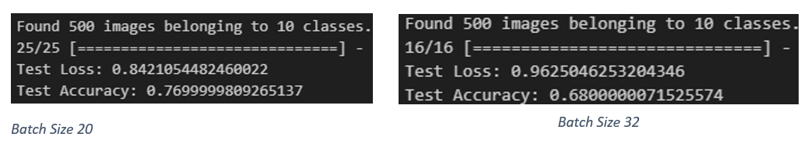

I used Batch size 32 which had a higher validation accuracy but might have lower test accuracy here as the number of batches to process from the test generator before declaring the evaluation process finished reduced with higher batch size so the test evaluation is stopped faster. Hence, I don’t think this test was representative of the actual test accuracy of batch size 32

### Decreasing Model Complexity

### Removal of Dense Layer

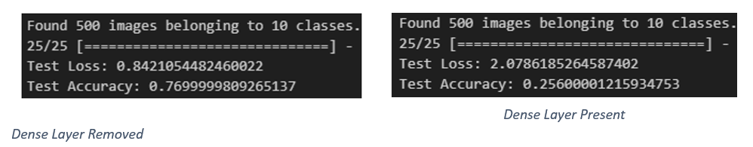

The removal of the second last dense layer boosted the test accuracy and I continued building my models without the dense layer.

### Image Size Reduction

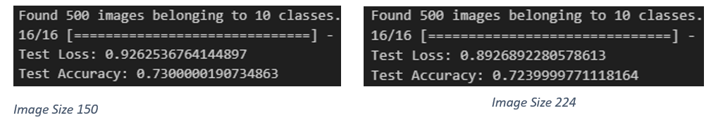

Decrease in image size introduced significant amount of noise which is less reliable because its predictions can be highly variable, making it difficult to trust its predictions and use it for real-world applications.

### Increasing Model Complexity

### Increasing Filter Size

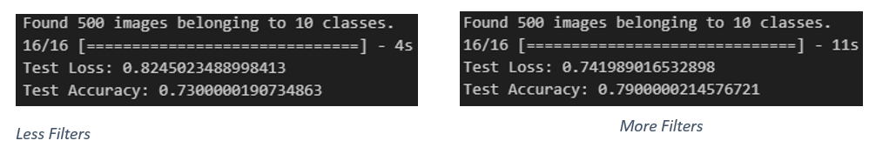

Increase in filter size introduced significant amount of noise which is less reliable because its predictions can be highly variable, making it difficult to trust its predictions and use it for real-world applications.

### Increasing Number of Convolutional Layers

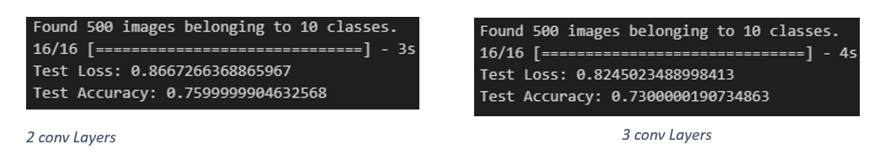

2 convolutional layers had a higher test loss and lower accuracy than 3 convolutional layers. This might be due to the small dataset and a simpler model being a better choice.

### Decrease Number of Max Pooling Layers

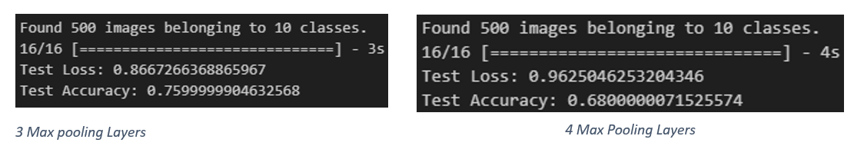

Reducing the number of max pooling layers can lead to the preservation of more spatial information in the feature maps which can lead to better generalisation and greater test accuracy.

### Batch Normalisation

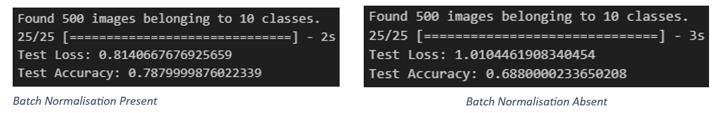

I decided not to use batch normalisation as it introduced too much noise which is not reliable

as predictions can be highly variable and make it difficult to trust model predictions.

### Activation Function

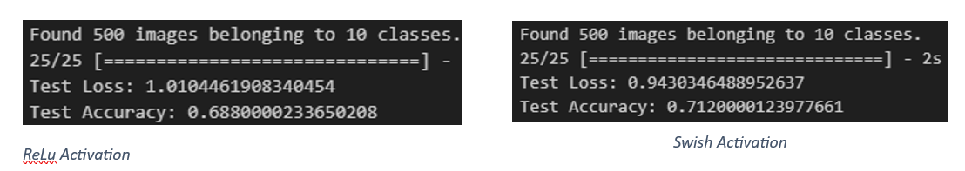

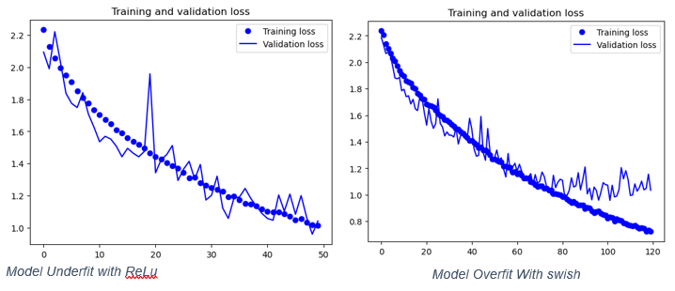

The swish activation function has higher test accuracy as the model overfit while training and trained for longer with swish but the model trained shorter and underfit when ReLu was used. At epoch 50, the model with ReLu had a lower validation loss of around 1.0 while swish had a validation loss of 1.2 at epoch 50. Hence, I decided to keep using ReLu.

### Pooling Type

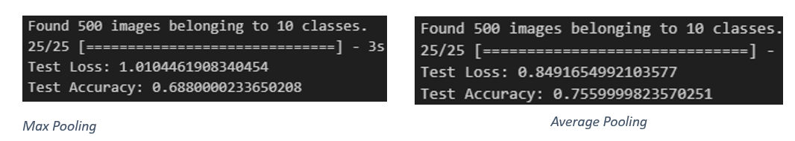

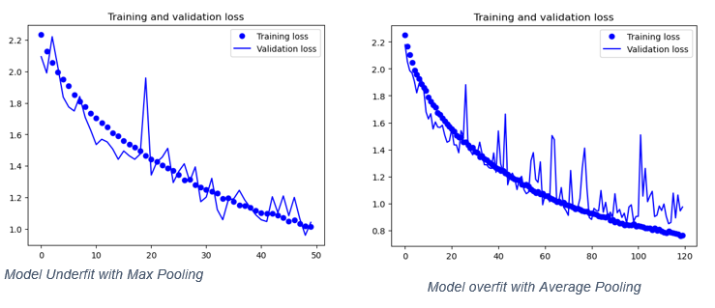

Average pooling has a higher test accuracy here as the model overfit while training and trained longer but the model trained shorter and underfit when max pooling was used. At epoch 50, the model with max pooling had a lower validation loss of around 1.0 while average pooling had a validation loss a bit below 1.2 at epoch 50. Hence, I decided to keep using max pooling.

### Optimizer

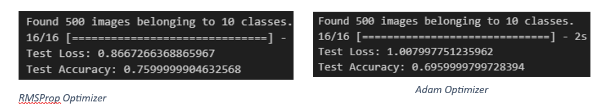

The RMSProp beat the Adam optimizer which meant that it was better for our use case and I continued using it.

### Learning Rate Scheduler

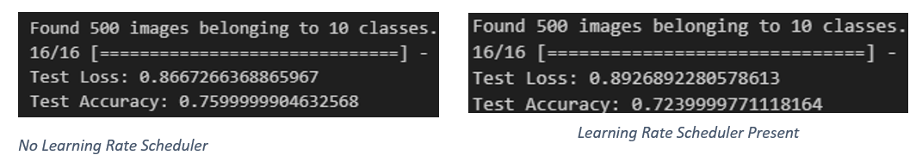

Learning rate scheduler was supposed to improve generalisation but it was failed to do that as the model with no learning rate scheduler had a higher test accuracy and hence, I did not use learning rate scheduler.

### Dropout

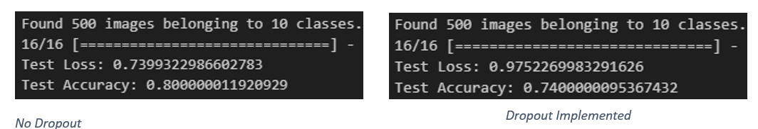

The model with dropout performed worse and this might be due to loss of information from the loss of useful neurons. Hence, I decided not to have dropout as overfitting was not a big problem for me.

### Baseline vs Best Scratch

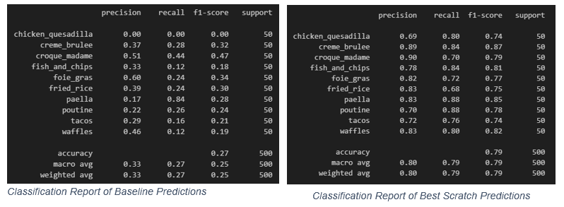

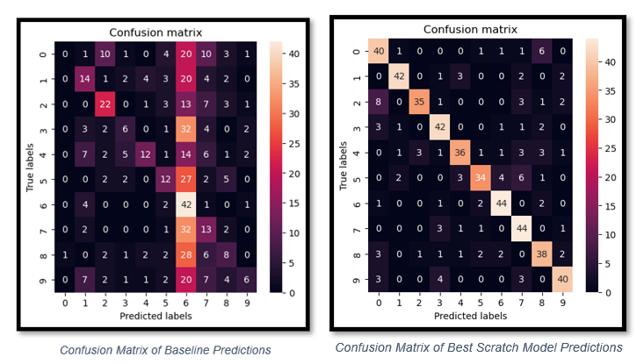

The best scratch model is much better than the baseline model and has achieved higher precision, recall, f1 score and accuracy for all classes.

Higher precision in multi classification indicates that a higher proportion of the predicted positive instances for a specific class are indeed correct, reducing false positives.

Higher recall in multi classification means that the model is better at identifying and capturing a larger proportion of actual positive instances across all classes, minimizing false negatives. It reflects the ability of the model to effectively recognize and retrieve instances belonging to each class, indicating improved sensitivity.

A higher F1-score indicates a better balance between precision and recall, suggesting that the model is effectively identifying and classifying instances for each class, considering both false positives and false negatives.

The confusion matrix shows that more images are correctly classified as there is higher predicted label corresponding to the true label.

A higher accuracy indicates a higher number of correctly classified data instances over the total number of data instances. In this case, 79% of the 500 images were correctly classified, 52% more than the baseline.

### Pre-Train Model Evaluation

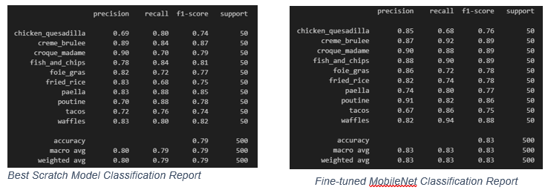

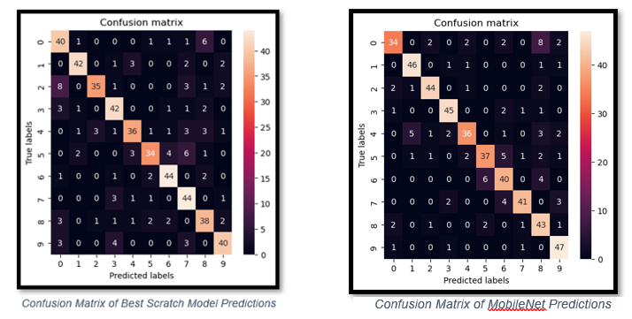

The fine-tuned MobileNet model has a higher accuracy which indicates a higher number of correctly classified data instances over the total number of data instances. In this case, 83% of the 500 images were correctly classified, 4% greater than my best scratch model.

The MobileNet model has higher f1-scores across the classes, indicating that the model is more effectively considering false positives and false negatives.

Hence, we can conclude that the MobileNet model is the best model that I have created.

# Image Classification using the Best Model

Now I will be testing the model out on real life images and evaluating the performance of the model on new images from unknown sources. This assesses the model’s generalization ability and performance on real-world, unseen data. This helps identify whether the model has learned meaningful patterns and features that extend beyond the training data, ensuring its reliability in diverse and practical scenarios.

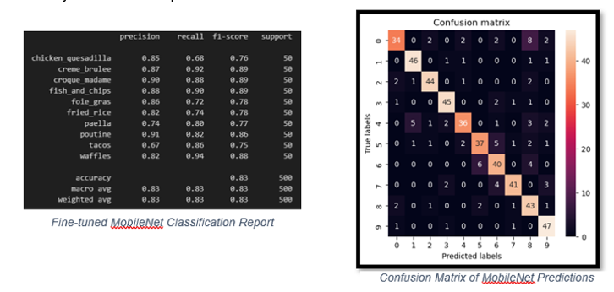

### Classifying Strongest Food Class

Looking at the confusion matrix of the MobileNet model, we can see that it is able to classify class 9, waffles most effectively, correctly classifying 47 out of 50 images correctly. Hence, I first started by testing the model on a waffle image from the internet.

### Waffle Image With Little Noise

I first decided to find out the model’s predicted probability for an image of waffles with very little noise and where the main subject of the image is a waffle. I also chose a fairly clear image.

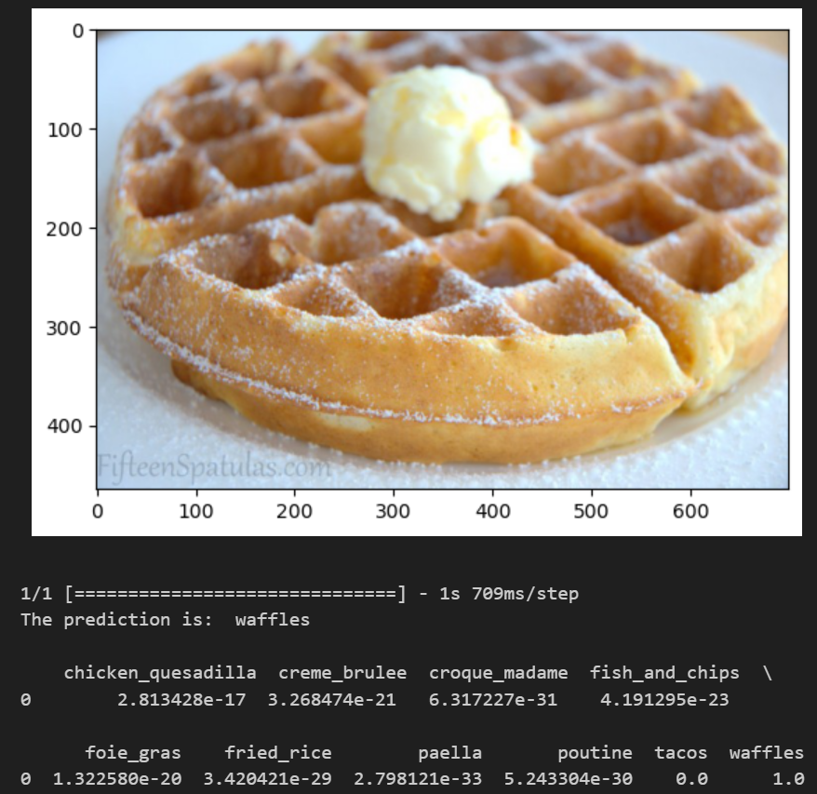

Image Classification of waffle image with less noise

The model was able to confidently classify the image as a waffle with probability of 1, which is 100%. The other classes have very low predicted probabilities, approaching zero,

indicating that the model is highly confident in its prediction for the "waffles" class.

### Waffle Image With More Noise

Then I chose an image that had a lot of noise, which had unwanted or irrelevant elements, distortions, or variations that can interfere with the clarity and quality of the visual information as I was curious of changes in predicted probability.

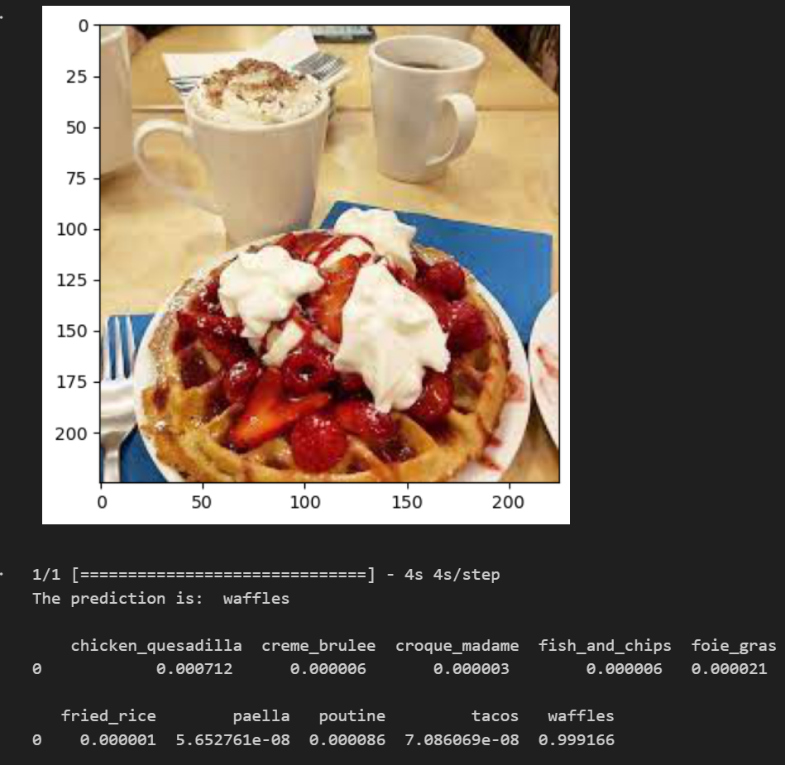

Image Classification of Waffle Image with More Noise

As expected, the predicted probability decreased to 0.999166 from 1. Noise in images can manifest as random patterns, artifacts, or inconsistencies in pixel values, making it challenging for image processing algorithms to accurately interpret and classify the content.

### Classifying Weakest Food Class

I wanted to find out the difference of the predicted probability between classifying the most effective class, waffles and the least effective class, chicken quesadilla, correctly classifying only 34 out of 50 images correctly.

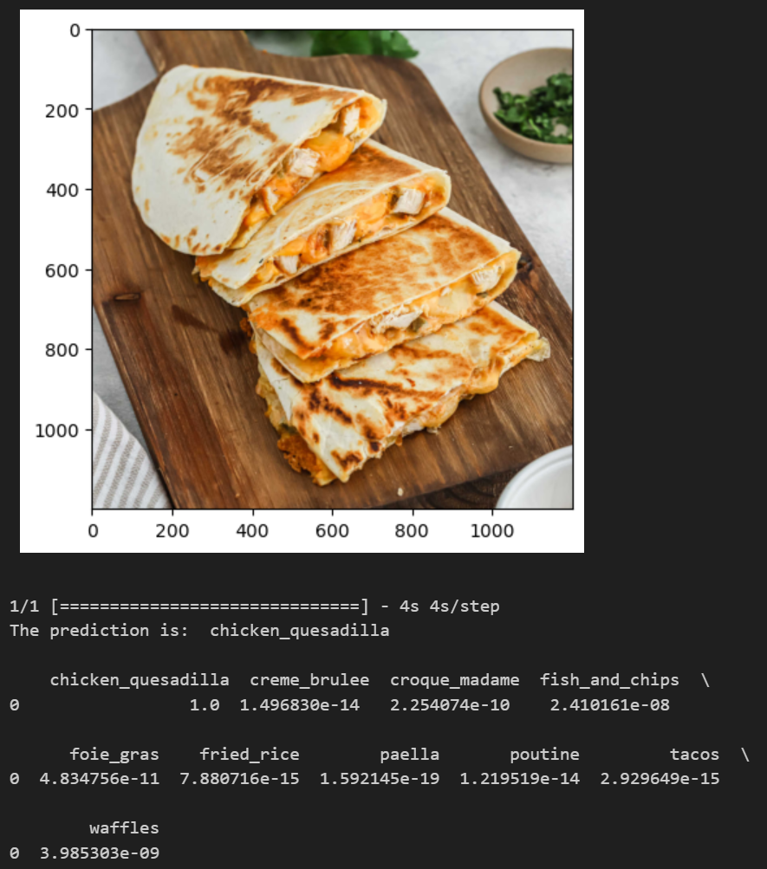

Image Classification of Chicken Quesadilla

To my surprise, the model was able to classify the chicken quesadilla image with a predicted probability of 1. I was expecting a lower number since it was not able to correctly classify 68% of chicken quesadilla images correctly in the test set.

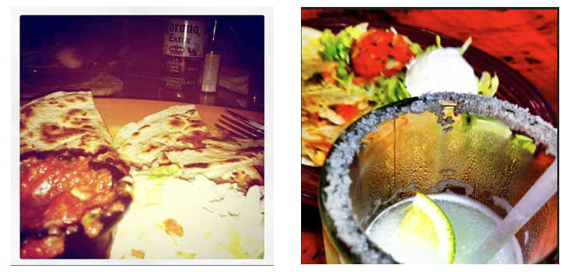

Examples of images in chicken quesadilla folder of test

Upon investigation, I found that many images in the test set were noisy and had variations in colour, blur and did not have the chicken quesadilla as the main subject, making it challenging for image processing algorithms to accurately interpret and classify the images.

### Finding out how model classifies Wrong Images

Next, I was interested as to how the model would classify food items which were not in the 10 classes it was trained to classify.

When I was exploring the data, I came across an image in the ‘poutine’ food class folder of the train set.

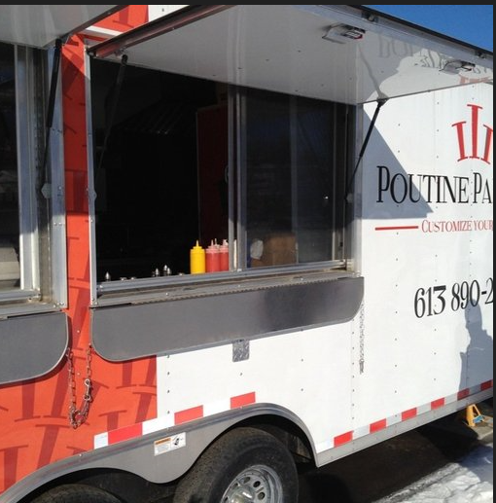

Incorrect Image Example from Poutine Train Set

It was an image of a food truck and with no signs of poutine food item in the image. Hence, I decided to find a similar image and find out which class the model classifies it under.

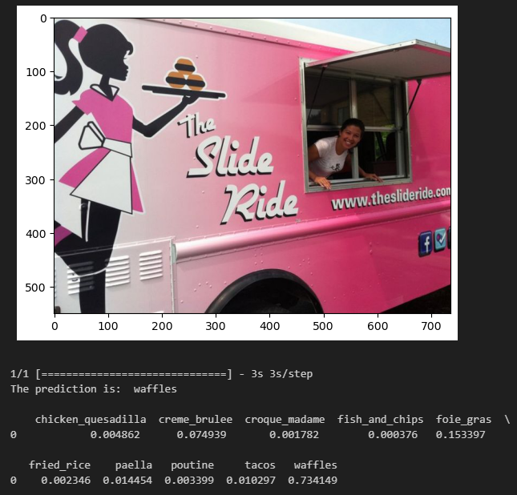

Food Truck Image From Internet Classification

I was surprised that the model classified the food truck image to the waffle class with 0.73 probability as I was expecting it to get classified to the poutine folder.

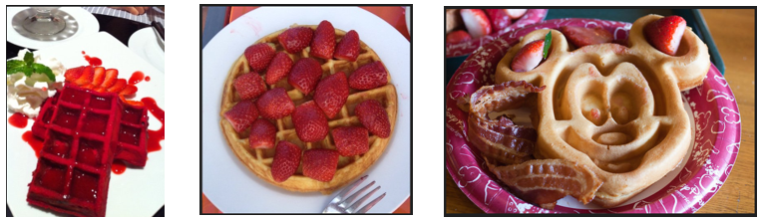

Examples of Waffle Images in Train Set which had pink and red

Upon investigation of the waffle class of the train set, I found that many waffle images had pink or red in them as many of the images had strawberries in them. I think that when the model was classifying the pink food truck above, it classified it to the waffle class due to its pink colour.

# Summary & Reflection

In summary, we have explored the methods to build and evaluate an image classification model for multi class classification, both from scratch and by using transfer learning. To iterate once again, for any deep learning problem, the ideal workflow is:

1. Problem Understanding

Problem understanding helps with selecting relevant assessment criteria, addressing moral dilemmas, and guaranteeing that the model fits the nature of the issue and the facts at hand.

1. Planning

Model building requires a lot of different changes and testings and the process can become extremely messy which can lead to problems down the road as one might become confused and lost.

1. Data Preprocessing

Splitting data into training, validation, and test sets is crucial for model development. Training data teaches the model, validation data helps tune parameters, and the test set assesses generalization performance, ensuring models work well on new, unseen data.

1. Data Augmentation

Data augmentation was done in our case to increase the number of images the model can learn from. This was especially important due to the small dataset for training the model.

1. Building Deep learning model

It is ideal to start with a baseline model with a simple architecture to set as a reference point and start making the model better from there. Transfer learning can also be used as a more powerful alternative to building models from scratch as it is less time-intensive, less computationally expensive and overall easier to implement.

1. Evaluating Model using test data and real life images

Lastly, we evaluate the models built on the test data to further understand how well they generalise on new and unseen data and for multi-class classification, it also aid understanding of the classes where the model is not classifying well.

### Further Improvements

1. DCGAN (Deep Convolutional Generative Adversarial Network)

The purpose of DCGAN is to generate realistic images by training a generator network to create images that are indistinguishable from real ones, while a discriminator network learns to differentiate between real and generated images. This could be especially helpful in our case with a small dataset.

1. Further Tests

More tests can be done with more variety of architectures and model configurations to achieve the best possible model for this use case.

### Personal Reflection

After this assignment, I have a greater value for time and have understood first-hand the pains of deep learning. I realised that I should have started the assignment on the same week we received it after I started building and running the models. I feel like if I had started earlier, I would have achieved a better model from scratch as I could have played around with more model architectures and configurations. However, looking back, I am proud of myself and can give myself a pat on my back for managing to complete this assignment and managing to get a model that had a high accuracy and only a few percent behind the pre-trained model. It was a difficult journey filled with stress and worries. This was the first time I have created so it was a big eye-opener into the world of deep learning.